Member Survey 2026
Policy priorities, member engagement and business outlook

Intro | ABOUT THIS SURVEY  This survey directly shapes DIGITALEUROPE’s policy priorities for 2027. By sharing what matters most to your organisation, you help us focus our efforts and resources on the issues that impact you and the entire DIGITALEUROPE membership the most. Your input also allows us to engage your team on the policy issues and projects that will provide the greatest strategic value to you.  The survey is structured in three parts:  1. Policy Prioritisation: Rank the most important policy issues for your organisation  (Category 1, 2 and 3 - see details on what each category means on the next page).  2. Member satisfaction & project engagement: Share your organisation’s perception of the value of its DIGITALEUROPE membership and the effectiveness of our policy priorities. And let us know if you are interested in working with our projects team.  3. EU Business Environment: Tell us your experience with the European business environment. DIGITALEUROPE has been collecting data from its members for a few years to use it in our advocacy actions.  Please coordinate internally before casting your vote. We recommend using the Word version of the survey for internal consultation before completing the final online submission.  Only one submission per organisation is allowed.  This survey is estimated to require approximately 30 minutes to complete.  Deadline: Friday 16 October 2026, at 18:00 CET.  Cecilia Bonefeld-Dahl & Peter Weckesser  Director General & President of DIGITALEUROPE
Please enter your email address for verification purposes:
Surname
Name

Email address
Organisation name
[drop-down list]

HOW TO COMPLETE THIS SURVEY

1. Review the issues across all six Policy Groups, read their descriptions and select those your organisation wishes to prioritise. You may also download all issue descriptions in bulk here.

2. On the next page, categorise your selected issues using the tables provided. You may choose up to 5 Category 1, 15 Category 2 and 20 Category 3 issues. A summary will display your choices at the bottom of the survey.

3. Membership value and projects: Share your feedback on DIGITALEUROPE and your organisation’s interest in EU-funded projects.

4. EU business environment: Tell us about your organisation’s experience with doing business in Europe.

Confirmations
☐ I confirm that I am answering on behalf of my organisation and that I have coordinated with my colleagues before submitting a response.*
☐ I understand that these answers will be solely used for internal purposes. Your responses will remain strictly confidential and will not be disclosed to external parties.*

[Next Page Button]

PART 1: POLICY PRIORITIES FOR 2027

Intro | ABOUT OUR POLICY PRIORITISATION PROCESS  Member input determines where DIGITALEUROPE focuses its advocacy and resources. Our current 96 policy issues are grouped into four categories according to the level of activity required:  - CATEGORY 1: Our most strategic and resource-intensive issues, both from a position-making and outreach perspective.  - CATEGORY 2: Issues requiring active medium advocacy;  - CATEGORY 3: Issues requiring targeted, mainly technical engagement;  - CATEGORY 4: Issues to be monitored and discussed by members, without planned advocacy or deliverable.  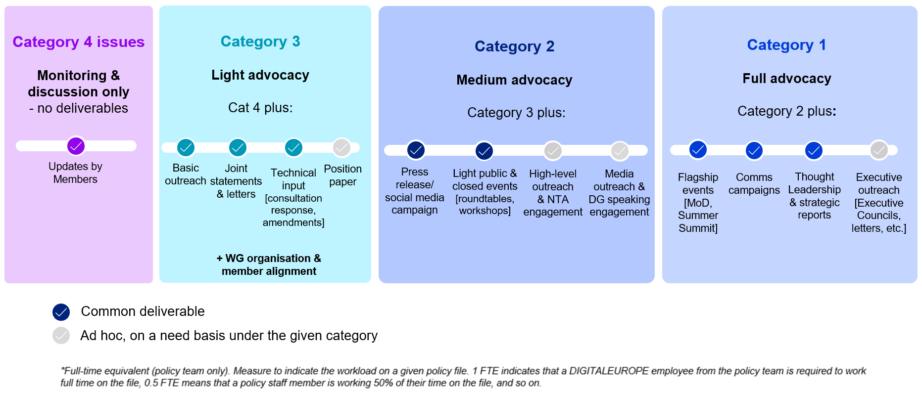  GOVERNANCE AND DECISION-MAKING  After the survey, Policy and Working Group Chairs will review the results against available resources. The Board will then approve the final 2027 workplan on 18 November, which will be reviewed quarterly and adjusted when needed by the Policy and Working Chairs. For more information about the process, click here.  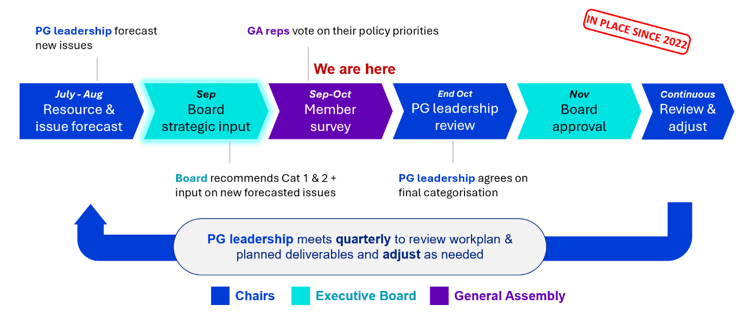  BOARD RECOMMENDATIONS  In August 2026, the Operations Committee advised focusing staff time on fewer files to increase impact, by prioritising a smaller set of strategic Category 1 files while keeping capacity for emerging priorities. In September 2026, the Executive Board identified five potential Category 1 issues (highlighted in the survey). The five issues receiving the most member votes will be proposed to the Board for final approval.  ___________________________________________________________________________  Step 1: Select the policy issues your organisation is interested in  Review the policy issues listed below across all six Policy Groups. Use the information icon beside each issue to read its description, then select every issue your organisation wishes to prioritise. Find a description of all issues here.  You may choose up to 5 Category 1, 15 Category 2 and 20 Category 3 issues.  On the next page, you will be asked to categorise your selected issues as Category 1, 2 or 3.

DATA ECONOMY POLICY GROUP

Q1. Please select the issues most relevant to your organisation from the list below. You can categorise them by importance into Category 1, 2 or 3 on the next page:

See a description of all the issues here.
Recommended by Board as Category 1
☐ Cloud and AI Development Act (CADA)
☐ Digital simplification (Digital Omnibus & Data Union Strategy)

Issues in current workplan
☐ AI Act Implementation
☐ AI in the workplace (Quality Jobs Act)
☐ AI Liability
☐ AI standardisation
☐ Audiovisual Media Services Directive (AVMSD): Implementation & Review
☐ Child sexual abuse material (CSAM) Regulation
☐ Consumer Package (Digital Fairness Act, Consumer Protection Cooperation (CPC) revision)
☐ Copyright & AI
☐ Data Act implementation
☐ Digital Markets Act (DMA) implementation
☐ Digital Services Act (DSA) implementation
☐ EU IPR policy
☐ EU-US personal data flows
☐ GDPR Review & Implementation
☐ Private Copying Levies
☐ Product Liability Directive implementation
☐ Right to Repair Directive implementation

Potential new issues
☐ KIDS Act

DIGITALLY ENABLED TRANSFORMATION POLICY GROUP

Q2. Please select the issues most relevant to your organisation from the list below. You can categorise them by importance into Category 1, 2 or 3 on the next page:

See a description of all the issues here.
Issues in current workplan
☐ AI in Financial Services
☐ AI in healthcare
☐ Action plan on digitalisation and AI for water
☐ Automotive Action Plan
☐ Autonomous Driving
☐ Data Centres incl. sustainability label and standards, energy, waste heat, and water
☐ Digital Euro
☐ Digital Operational Resilience Act (DORA)
☐ Electrification Action Plan & legal proposal on network charges
☐ Energy Efficiency Framework
☐ EU initiatives on cybersecurity of hospitals and life sciences
☐ European Grids Package
☐ Financial Data Access Regulation (FIDA)
☐ Health Data (European Health Data Space)
☐ In-Vehicle Data
☐ Mobility omnibus
☐ Payment services
☐ Roadmap for Digitalisation and AI in energy
☐ Savings and Investments Union
☐ Tokenisation of Financial Services
Potential new issues
☐ Competitiveness of the banking sector
☐ Mobility under CSA2

INTERNATIONAL RELATIONS & TRADE POLICY GROUP

Q3. Please select the issues most relevant to your organisation from the list below. You can categorise them by importance into Category 1, 2 or 3 on the next page:

See a description of all the issues here.
Recommended by Board as Category 1
☐ EU-US relations

Issues in current workplan
☐ EU-China relations
☐ EU-Japan relations
☐ EU-UK relations
☐ International dimension of priority issues (AI, Cyber, etc.)
☐ Multilateral trade and economic engagements (WTO)
☐ Trade barriers to non-EU markets (MAAC)
☐ Trade Climate & Customs Measures
☐ Trade Security Measures (export controls)
Potential new issues
☐ EU-India relations

RESILIENCE & INFRASTRUCTURE POLICY GROUP

Q4. Please select the issues most relevant to your organisation from the list below. You can categorise them by importance into Category 1, 2 or 3 on the next page:

See a description of all the issues here.
Recommended by Board as Category 1
☐ CSA2: Cybersecurity Act revision and EU cybersecurity certification (EUCC, EUCS and SCGG)
☐ EU Defence Funding (EDIP, SAFE, etc.)

Issues in current workplan
☐ Cyber Resilience Act
☐ Cyber Solidarity Act
☐ Cybersecurity Standardisation
☐ Digital Networks Act (including spectrum)
☐ Digital Omnibus (Cyber)
☐ European Business Wallet
☐ International harmonisation of cyber rules
☐ NIS 2 Directive
☐ Public-Private Partnerships
☐ Revision of Public Procurement Directives

Potential new issues
☐ European Blueprint for secure access to advanced AI systems for cybersecurity purposes

SINGLE MARKET AND COMPETITIVENESS POLICY GROUP

Q5. Please select the issues most relevant to your organisation from the list below. You can categorise them by importance into Category 1, 2 or 3 on the next page:

See a description of all the issues here.
Issues in current workplan
☐ 28th regime for businesses
☐ Critical Raw Materials Act
☐ Digital Product Passport (DPP)
☐ European Chips Act 2.0
☐ EU Product Act (Standardisation Regulation, NLF & MSR)
☐ Horizon Europe
☐ Investment & Incentives (incl. EIB, TechEU, Scaleup Fund)
☐ Multi-annual Financial Framework negotiations (incl. European Competitiveness Fund)
☐ Participation in relevant standardisation activities (e.g. ESOs, HLF, MSP, etc.)
☐ Quantum Act
☐ Strengthening the Single Market (barriers reduction)
☐ Technical Regulation: Radio Equipment Directive (RED)
☐ Union of Skills: Tech Talent and Digital Education

SUSTAINABILITY POLICY GROUP

Q6. Please select the issues most relevant to your organisation from the list below. You can categorise them by importance into Category 1, 2 or 3 on the next page:

See a description of all the issues here.
Issues in current workplan
☐ Batteries Regulation (sustainability, safety & due diligence)
☐ Circular Economy Act (incl. WEEE Directive)
☐ Ecodesign for Sustainable Products Regulation (ESPR) Horizontal Framework
☐ Environmental omnibus
☐ EU Deforestation Regulation
☐ EU Persistent Organic Pollutants Regulation
☐ Forced Labour Regulation
☐ Lot 3 (Computers and computer servers)
☐ Lot 4 (printers)
☐ Lot 5 (electronic displays)
☐ Lot 6/26 (Standby, networked standby, and off mode)
☐ Lot 7 (external power supplies)
☐ Lot 9 (servers and data storage products)
☐ Packaging and Packaging Waste Regulation​
☐ REACH restrictions & PFAS
☐ REACH simplification
☐ RoHS revision and exemption
☐ Sustainability Omnibus implementation (CSRD/ESRS, CSDDD, Taxonomy)
☐ Waste Shipments Regulation
Q7. Is there any policy issue not listed above that you would recommend DIGITALEUROPE to work on?
[Comment box]

[Next Page Button]

PART 1: POLICY PRIORITIES FOR 2027

Step 2: Categorise your selected policy issues
The issues you selected on the previous page are shown below, grouped by Policy Group. Choose Category 1, 2 or 3 for each issue, with a maximum of 5 Category 1, 15 Category 2 and 20 Category 3 choices.

To add or remove an issue, return to the previous page and either check it or uncheck it.
A summary of your choices will appear at the bottom of the page. Please review it before continuing.

Per Policy Group
Please categorise your selected issues into Category 1, 2 or 3:

Issue Name | Category 1 | Category 2 | Category 3
… | ☐ | ☐ | ☐
 | ☐ | ☐ | ☐

You have selected the following [Nr.] Category 1 issues:
Please verify that the list is correct: …

You have selected the following [Nr.] Category 2 issues:
Please verify that the list is correct: …

You have selected the following [Nr.] Category 3 issues:
Please verify that the list is correct: …

[Next Page Button]
PART 2: DIGITALEUROPE’s membership value & project engagement
Membership Satisfaction & Value: Please share how your organisation perceives the value of its DIGITALEUROPE membership and our policy work.

Q8. | Overall, how satisfied is your organisation with the value it receives from its DIGITALEUROPE membership?*
Q8. | ☐ Very satisfied  ☐ Fairly satisfied  ☐ Neither satisfied or dissatisfied  ☐ Fairly dissatisfied  ☐ Very dissatisfied

Q9. | How would you describe DIGITALEUROPE’s external reputation?*
Q9. | ☐ Very good  ☐ Somewhat good  ☐ Neither good nor bad  ☐ Somewhat bad  ☐ Very bad  ☐ Don’t know

Q10. | How likely is it that your organisation will remain a member of DIGITALEUROPE over the next two to three years?*
Q10. | ☐ Very likely  ☐ Somewhat likely  ☐ Neither likely nor unlikely  ☐ Somewhat unlikely  ☐ Very unlikely  ☐ Don’t know

Q11. | How effective was DIGITALEUROPE’s work on the following Category 1 issues with which your organisation engaged in 2026?* [Matrix]  See a description of all the issues here.
Q11. | ☐ AI Act implementation (Very effective, Somewhat effective, Somewhat ineffective, Not effective, Didn’t interact)  ☐ Cloud and AI Development Act (CADA)  ☐ Cyber Resilience Act  ☐ Digital Defence: Shaping EU and NATO Defence Investments  ☐ Digital Simplification Package (AI & Data and Cyber)  ☐ EU-US relations  ☐ Multi-annual Financial Framework negotiations (incl. European Competitiveness Fund)  ☐ Sustainability Omnibus (CSRD & ESRS, CS3D & Taxonomy)

Project Engagement: DIGITALEUROPE currently participates in 18 EU-funded projects worth €5.5 million in areas including AI, cybersecurity, data spaces, digital skills, health, the twin transition, and e-inclusion. Around 10% of our members are involved, and we would like to engage more.

Q12. | How has your organisation previously engaged in EU-funded or other collaborative projects?*  Select all that apply:
Q12. | ☐ Coordinator or consortium partner  ☐ Advisory, validation or industry-expert role  ☐ Funder or sponsor  ☐ No previous involvement  ☐ Don’t know

Q13. | How would your organisation be interested in engaging with DIGITALEUROPE’s projects?*  By engaging in EU projects with DIGITALEUROPE your organisation can: 1) Access the latest research and innovation developments 2) Drive innovation within the digital sector 3) Influence the implementation of key digital initiatives 4) Engage with specialized stakeholder networks 5) Explore funding and business opportunities
Q13. | ☐ Join a consortium where relevant  ☐ Advise on industry needs or validate project outputs without any administrative efforts  ☐ Receive information about funding opportunities only  ☐ No interest in project engagement

Q13a. | In which areas is your organisation currently active or interested in engaging through projects? Select all that apply:*
Q13a. | ☐ Artificial Intelligence and data  ☐ Cybersecurity, defence and resilience  ☐ Data spaces and data sharing  ☐ Digital skills, talent and workforce transformation  ☐ Digital health and life sciences  ☐ Green and digital transition, including digital energy  ☐ Public-sector digitalisation and interoperability  ☐ Accessibility, inclusion and gender equality  ☐ Quantum technologies  ☐ Space, drones and autonomous systems  ☐ Standardisation  ☐ Other

Q13b. | Who should we contact in your organisation about relevant project opportunities:*
Q13b. | ☐ Contact me directly using the details provided earlier in this survey  ☐ Contact a colleague directly — please provide their details below:  ☐ We do not wish to be contacted about project opportunities  Job Title  Full Name  Email address

Communications Engagement: Please nominate a colleague we can contact to coordinate and amplify DIGITALEUROPE’s key messages, campaigns and announcements. They may receive communications toolkits, suggested social media content and relevant media opportunities.

Q14. | Who is the best communications point of contact in your organisation?*
Q14. | ☐ Contact me directly using the details provided earlier in this survey  ☐ Contact a colleague directly — please provide their details below:  ☐ We do not wish to be contacted about communication opportunities  Job Title  Full Name  Email address

[Next Page Button]

PART 3: EU Business Environment
Confidentiality: Individual responses will remain confidential and will not be disclosed. Anonymised, aggregate findings may be used to inform DIGITALEUROPE’s advocacy and communications.

Q15. | In the past year, how has the business environment for digital or digitalising companies evolved in Europe?  Please consider factors such as: clear and consistent regulatory and reporting requirements across Member States, accessibility and relevance of public funding for digital, access to private investment, etc.
Q15. | ☐ Improved  ☐ Remained the same  ☐ Worsened

Q16. | In the past year, how have legal and compliance costs for the operations of your organisation in Europe changed?  Please consider the costs that your organisation undergoes to comply with the regulation at both national and EU level.
Q16. | ☐ Decreased  ☐ Remained broadly the same  ☐ Increased by approximately 10%  ☐ Increased by approximately 20%  ☐ Increased by more than 20% (please specify by how much approximately)

Q16a. | Please mention regulatory areas that have been particularly costly. [comment box]

Q17. | In which region is your organisation currently experiencing the fastest growth?
Q17. | ☐ Europe  ☐ United States  ☐ South America  ☐ Africa  ☐ China  ☐ Rest of Asia

Q18. | Over the next three years, how well positioned are businesses in each of the following markets to achieve growth through AI? [Matrix]
Q18. | ☐ European Union (Very well positioned, Fairly well positioned, Fairly poor positioned, Very poorly positioned, Don't know)  ☐ United States  ☐ China

Q18a. | What advantages do businesses in the EU have in achieving growth through AI? [comment box]

Q18b. | What barriers make it harder for businesses in the EU to achieve growth through AI? [comment box]

Q19. | Over the next three years, how do you expect AI to affect your organisation or the businesses you represent?
Q19. | ☐ Increase growth and increase jobs  ☐ Increase growth with broadly the same number of jobs  ☐ Increase growth but reduce jobs  ☐ Have little impact on growth but reduce jobs  ☐ Reduce growth and reduce jobs  ☐ Have little impact on either growth or jobs  ☐ Don’t know

Q20. | Over the next three years, will the following factors help or hinder AI-driven business growth in the EU: [Matrix]
Q20. | ☐ Implementation of the EU AI Act (Major enabler, Somewhat an enabler, Neither an enabler nor a barrier, Somewhat a barrier, Major barrier, Don't know)  ☐ EU data and data-sharing rules  ☐ Europe’s manufacturing base and capabilities  ☐ Availability of investment and growth capital  ☐ Access to computing capacity and digital infrastructure  ☐ Availability of digital skills  ☐ Availability and cost of energy  ☐ Public investment and procurement
____________________________________________________________________________________

Thank you for taking your time to finish this survey and your participation.

Before you submit your answers, do you have any additional feedback to share with us? Your feedback is very important to help us continuously improve our work and impact.

Q.21 | Do you have any other feedback you would like to share with us?* [comment box]

Q.22 | Additional notification recipients  You will receive an email with a summary of your choices. Is there anyone else that should be notified about your vote? Please enter their email address below
 | Email address

Should you have any question, please contact leonie.boehnke@digitaleurope.org.

[Submit your response - End of survey]

