DIGITALEUROPE Member Priorities Survey 2024

Intro | This survey directly shapes DIGITALEUROPE’s policy priorities for 2025. By sharing what matters most to your organization, you help us focus our efforts and resources on the issues that impact you and the entire DIGITALEUROPE membership the most. Your input also allows us to engage your team on the policy issues and projects that will provide the greatest strategic value to you.  The survey covers:  - Policy Prioritisation: Rank the most important policy issues for your organisation (Category 1, 2 and 3);  - Project Engagement: Indicate your interest in project areas and share your experience with EU projects.  Please coordinate internally before casting your vote. We recommend using the Word version of the survey for internal consultation before completing the final online submission. Only one submission per organisation is allowed.  Deadline: Friday 25 October 2024, at 18:00 CET.  Cecilia Bonefeld-Dahl & Peter Weckesser  Director General & President of DIGITALEUROPE  Please select the organisation on behalf of which you are responding and provide your name, surname and work email for verification purposes:  Organisation name  [drop-down list]  Name  Surname  Email address  This survey is estimated to require approximately 30 minutes to complete.  If you are uncertain about your organisation's priorities, we encourage you to consult first with your colleagues using the word version, prior to submitting your response via this online survey. Only responses submitted via the online version will be considered.  Confirmations  ☐I confirm that I am answering on behalf of my organisation and that I have coordinated with my colleagues before submitting a response.*  ☐I understand that these answers will be solely used for internal purposes. Your responses will remain strictly confidential and will not be disclosed to external parties.*  [Next Button]

PART 1: POLICY PRIORITIES FOR 2025

Intro | ABOUT OUR POLICY PRIORITISATION PROCESS  At DIGITALEUROPE, we prioritize our advocacy based on direct input from members. This ensures that our efforts align with your needs and focus on the policy issues that deliver the most value for the entire membership.  We currently work on 86 policy files, categorised based on their importance to our members:  - CATEGORY 1 issues are the most strategic files on which DIGITALEUROPE concentrates most of its advocacy work, both from a position-making and outreach perspective;  - CATEGORY 2 issues are important policy files which deserve a medium level of advocacy;  - CATEGORY 3 issues are policy files that we follow and where we mostly engage at technical level.  *We have recently introduced a Category 4 to reflect policy files in our current workplan that we only monitor and provide space for discussion amongst members, but for which we do not foresee any specific deliverable.  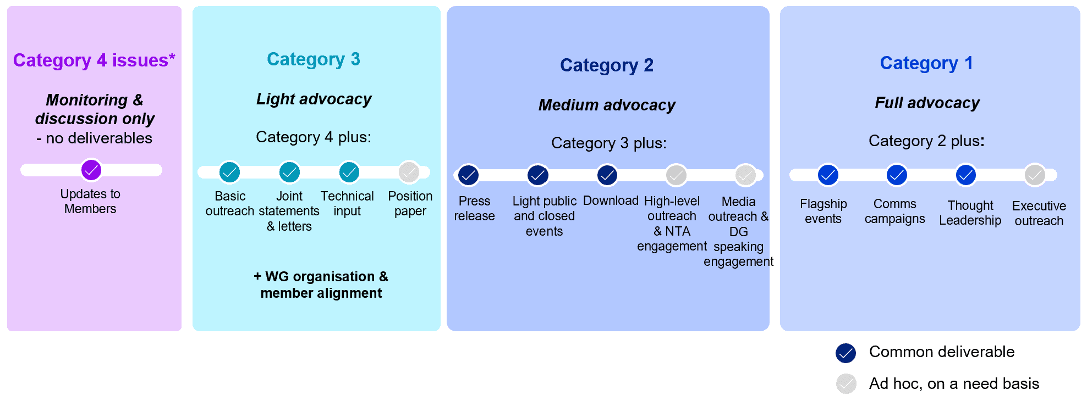  GOVERNANCE AND DECISION-MAKING  After the survey closes, the Chairs and Vice Chairs of Policy & Working Groups will review the results and recommend adjustments if necessary, based on available resources within each Policy Group. The Board will then approve the final categorization for DIGITALEUROPE’s 2025 work plan. The work plan is reviewed quarterly by the leadership of all Policy & Working Groups, with additional reviews as needed.  For a detailed overview of the process, click here.  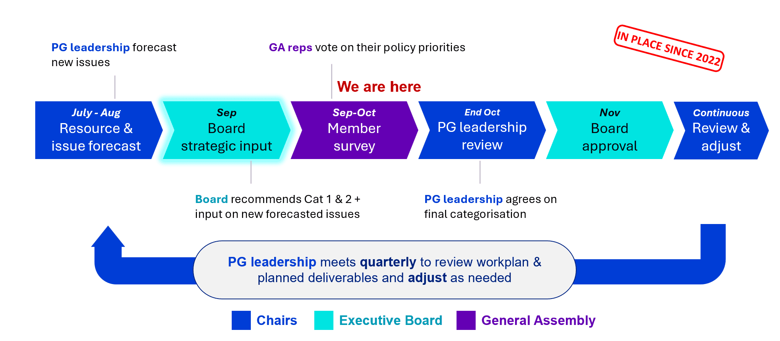  BOARD RECOMMENDATIONS  During the Strategy Days in Sep 2024, the Board recommended seven Category 1 issues, which are clearly indicated below.  In addition, the Board identified several other important Category 1 issues that were not shortlisted: Digital Networks Act, European Standardisation Policy, Clean Industrial Deal, New Circular Economy Act, Ecodesign for Sustainable Product Regulation (ESPR), REACH Restrictions & PFAS, and Private Copying Levies.  The Board also shortlisted forecasted issues, which are included in this survey for your consideration.  HOW TO FILL IN THE SURVEY  Please select the issues most relevant to your organisation from the list below and categorise them by importance:  - You may select up to 7 Category 1 policy issues  - You may select up to 20 Category 2 policy issues  - There are no limits for Category 3 policy issues, but we encourage you to be as selective as possible to reflect your organisation's top priorities  A short description for each policy issue is provided in this Annex.

DATA ECONOMY POLICY GROUP

Q1. Please select the issues most relevant to your organisation from the list below and categorise them by importance into Category 1, 2 or 3:

See a description of all the issues in the Annex.
Recommended by Board as Category 1
☐AI Act Implementation (Category 1 / Category 2 / Category 3)
☐New European Data Economy Strategy

Issues in current workplan
☐AI Liability (Category 1 / Category 2 / Category 3)
☐Child Sexual Abuse Material (CSAM) Regulation
☐Copyright & AI
☐Data Act implementation
☐Digital Fairness Act
☐Digital Markets Act implementation
☐Digital Services Act implementation
☐EU IPR policy
☐EU-UK data flows
☐European Media Freedom Act (guidelines on prominence)
☐GDPR review & implementation
☐Private copying levies
☐Product Liability Directive implementation
☐Right to repair proposals
☐Transatlantic data transfers

Potential new issues
☐AI and data contract rules for the digital economy (Category 1 / Category 2 / Category 3)
☐AVMSD Audiovisual Media Services Directive (AVMSD): Implementation & Review
☐Cyberbullying action plan
☐EU Action Plan on Cyberbullying
☐European Democracy Shield
☐ePrivacy follow up
☐Protection of Minors Online
☐Revision of the Consumer Protection Cooperation (CPC) network Regulation
☐SCCs for EU institutions and bodies to transfer personal data to third countries
☐Third Party Litigation Funding

SUSTAINABILITY POLICY GROUP

Q2. Please select the issues most relevant to your organisation from the list below and categorise them by importance into Category 1, 2 or 3:

See a description of all the issues in the Annex.
Recommended by Board as Category 1
N/A

Issues in current workplan
☐Batteries Regulation (sustainability, safety & due diligence) (Category 1 / Category 2 / Category 3)
☐Corporate Sustainability Due Diligence Directive (CS3D)
☐Ecodesign for Sustainable Products Regulation (ESPR)
☐European Sustainability Reporting Standards (ESRS)
☐Forced Labour Regulation
☐Green Claims Directive
☐Lot 3 (Computers and computer servers)
☐Lot 4 (printers)
☐Lot 5 (electronic displays)
☐Lot 7 (external power supplies)
☐Lot 9 (servers and data storage products)
☐Packaging and Packaging Waste Regulation (PPWR)
☐REACH restrictions & PFAS
☐REACH revision & chemicals industry package
☐RoHS revision & exemptions
☐Waste Shipments Regulation
☐WEEE Directive

Potential new issues
☐Lot X (smartphones) (Category 1 / Category 2 / Category 3)
☐Lot 6/26 (Standby, networked standby, and off mode)
☐New Circular Economy Act

INTERNATIONAL RELATIONS & TRADE POLICY GROUP

Q3. Please select the issues most relevant to your organisation from the list below and categorise them by importance into Category 1, 2 or 3:

See a description of all the issues in the Annex.
Recommended by Board as Category 1
☐EU-US relations (Category 1 / Category 2 / Category 3)

Issues in current workplan
☐Coordination with international forums (Category 1 / Category 2 / Category 3)
☐EU-China relations
☐EU-India relations
☐EU-Japan relations
☐EU-UK relations
☐International dimension of priority issues (AI, Cyber, Green, etc.)
☐Non-EU Market Access (MAAC)
☐Trade Climate & Customs Measures
☐Trade Security Measures (dual use export controls and sanctions)
☐WTO Engagement
Potential new issues
N/A

SINGLE MARKET AND COMPETITIVENESS POLICY GROUP

Q4. Please select the issues most relevant to your organisation from the list below and categorise them by importance into Category 1, 2 or 3:

See a description of all the issues in the Annex.
Recommended by Board as Category 1
☐Horizontal Single Market Strategy (Category 1 / Category 2 / Category 3)

Issues in current workplan

☐Common Charger (Category 1 / Category 2 / Category 3)
☐Critical Raw Materials Act
☐Digital Education Action Plan
☐Digital Europe Programme
☐Digital Product Passport (DPP)
☐Electromagnetic Compatibility (EMC)
☐European Chips Act
☐European Standardisation Strategy (ESS)
☐Horizon Europe
☐Initiative on virtual worlds & Metaverse standardisation activities
☐Multiannual Financial Framework (MFF)
☐New Legislative Framework (NLF)
☐Quantum initiative
☐Radio Equipment Directive (RED)
☐VAT in the Digital Age

Potential new issues
☐European Competitiveness Fund (Category 1 / Category 2 / Category 3)
☐Collaboration with European Standardisation Organisations (ESOs)
☐Skills Portability Initiative

RESILIENCE & INFRASTRUCTURE POLICY GROUP

Q5. Please select the issues most relevant to your organisation from the list below and categorise them by importance into Category 1, 2 or 3:

See a description of all the issues in the Annex.
Recommended by Board as Category 1

☐EU Cloud Security Certification Scheme (EUCS) (Category 1 / Category 2 / Category 3)
☐Revision of Public Procurement Directives
Issues in current workplan

☐Cyber Resilience Act (CRA) (Category 1 / Category 2 / Category 3)
☐Cyber Solidarity Act (CSA)
☐Digital Networks Act (DNA)
☐eIDAS & interoperable EU wallet
☐EU Cyber Toolbox
☐Cybersecurity Act evaluation
☐European Defence Industrial Strategy
☐GAIA-X
☐NIS2 Directive
☐Spectrum management
☐Stakeholder Cybersecurity Certification Group (SCCG)
Potential new issues

☐Harmonisation of Cyber rules (Category 1 / Category 2 / Category 3)
☐Public Private Partnerships (PPPs)
☐Revision of EU Cybersecurity Strategy 2020
☐Revision of European Electronic Communications Code Directive

DITIGALLY ENABLED TRANSFORMATION POLICY GROUP

Q6. Please select the issues most relevant to your organisation from the list below and categorise them by importance into Category 1, 2 or 3:

See a description of all the issues in the Annex.
Recommended by Board as Category 1

☐Capital Markets Union (CMU) (Category 1 / Category 2 / Category 3)

Issues in current workplan

☐AI in financial services (Category 1 / Category 2 / Category 3)
☐Digital Euro
☐Digital Operational Resilience Act (DORA)
☐EFRAG Taxonomy
☐Financial Data Access Regulation (FIDA)
☐European Health Data Space (EHDS)
☐In-Vehicle Data
☐Payment services

Potential new issues

☐AI in healthcare (Category 1 / Category 2 / Category 3)
☐Clean Industrial Deal
☐Multimodal digital mobility services (MDMS)

Q7. Is there any policy issue not listed above that you would recommend DIGITALEUROPE to work on? [Comment box]

[Next Button]

PART 2: PROJECT ENGAGEMENT

Intro | Please take a few minutes to let us know about your organisation’s experience with and interest in EU projects. If you are unsure, please consult with a relevant person within your organisation who is knowledgeable about projects before answering the below questions.  DIGITALEUROPE is currently involved in 21 EU-funded projects totalling €4.5 million, primarily under the Digital Europe, Erasmus+, and Horizon Europe programmes. Currently, about 25% of our members actively participate in these projects, and we are eager to involve more.  Our projects align with our strategic policy priorities and focus on one of the seven areas listed below. The full list of projects we are currently implementing is available here:  - Artificial Intelligence  - Cybersecurity  - Data Spaces  - Digital Skills  - Digital Health  - Digital and Green Twin Transition  - E-Inclusion and Gender Equity

Q.8 | Has your organization previously engaged in EU-funded projects?* [Single-select]  - Yes (jump to Q.8.1)  - No (jump to Q.8.2)  - Not sure (jump to Q.8.2)

Q8.1 | What is the relation between your EU projects unit and your Public Affairs team?* [Single-select]  - We belong to the same team  - We are separate teams but collaborate closely  - We are separate teams with minimal collaboration  - We are separate teams without any collaboration  - Other: specify  (jump to Q.8.1.1)

Q8.1.1 | For how long has your organisation been involved in EU-funded projects?* [Single-select]  - 1-2 years  - 3-5 years  - More than 5 years  - Don’t know  (jump to Q.8.2)

Q8.2 | Would you be interested in engaging with DIGITALEUROPE on EU-funded projects?* [Single-select]  Benefits of Participation in Projects  By engaging in EU projects with DIGITALEUROPE your organisation can:  Access the latest research and innovation developments  Drive innovation within the digital sector  Influence the implementation of key digital initiatives  Engage with specialized stakeholder networks  Explore funding and business opportunities  - Yes (jump to Q.9)  - No (jump to thank you page & Q.12 & Q.13)

Q.9 | In which of the following areas is your organization currently engaged in EU projects or would be keen on participating?* [Multi-select]  - Artificial Intelligence  - Cybersecurity  - Data Spaces  - Digital Health  - Digital Skills  - Digital and Green Twin Transition  - e-Inclusion & Gender Equity  - Public administration (interoperability & procurement rules)  - Other: specify  (jump to Q.10)

Q.10 | To help us identify possible synergies, please provide the contact details of a person in your organisation we could reach out to regarding project opportunities:* [checkbox or short answers]  ☐Use the same contact details as provided earlier in this survey (if checked Q.11.1; if not checked Q.11.2)  Name and surname  Position  Email address

Q.11.1 | Would you or someone else like to be included in communications regarding project opportunities? [single-select]  - Please copy the following people: [comment box]

Q.11.2 | Would you or someone else like to be included in communications regarding project opportunities? [single-select]  - That’s not necessary; please get in touch with the indicated contact person  - Yes please, I’d like to stay informed about future EU project opportunities  - Please copy the following people: [comment box]

[Next Button]

Thank you page
Thank you for your response. Your input will play a key role in our prioritisation process, helping us focus on the policy issues that matter most to our members.

Before you go, we would appreciate it if you could rate your satisfaction with the opportunity to contribute to this process, and share any additional comments or suggestions you may have.

Q.12 | How satisfied are you with our policy prioritization process and the opportunity to provide input? [Star rating]*

Q.13 | Do you have any other feedback you would like to share with us regarding this process?? [Comment box]

[End of survey]

